BINARY LOGISTIC REGRESSION ANALYSIS
Generated on: 2026-05-19 05:18:22
Analysis of first-born vs later-born parity (binary outcome)

7.1 Binary Logistic Regression
Binary logistic regression was used to model the probability of being first-born (parity = 1) versus later-born (parity > 1). The model uses a logit link function and maximum likelihood estimation (MLE).
Outcome variable coding: 1 = First-born, 0 = Later-born

Model Fit Statistics
Metric | Value
Log-Likelihood (Full Model) | -150487.4392
Log-Likelihood (Null Model) | -176817.1285
Likelihood Ratio (LR) Statistic | 52659.3786
LR Test P-value | 0.000000
Pseudo R-squared (McFadden) | 0.1489
AIC | 301018.88
BIC | 301249.31
Number of Observations | 261544
Degrees of Freedom (Model) | 21.0
Degrees of Freedom (Residual) | 261522.0
✓ Likelihood Ratio Test is significant (p = 0.000000 < 0.05)
The model with predictors fits significantly better than the null model.

Regression Coefficients
Variable | Coef | Std Err | z-value | P>|z| | Odds Ratio | Sig
age_group_20-24 | -1.9603 | 0.0457 | -42.9135 | 0.0000 | 0.141 | ***
age_group_25-29 | -3.0082 | 0.0451 | -66.6804 | 0.0000 | 0.049 | ***
age_group_30-34 | -3.9516 | 0.0454 | -87.0228 | 0.0000 | 0.019 | ***
age_group_35+ | -4.5143 | 0.0464 | -97.3949 | 0.0000 | 0.011 | ***
marital_status_Unmarried | 0.2022 | 0.0447 | 4.5207 | 0.0000 | 1.224 | ***
race_mother_Indian Tamil | -0.0839 | 0.1301 | -0.6448 | 0.5190 | 0.920
race_mother_Malay | -0.3864 | 0.1719 | -2.2477 | 0.0246 | 0.679 | *
race_mother_Sinhalese | 0.0319 | 0.1284 | 0.2484 | 0.8038 | 1.032
race_mother_Srilankan Moor | -0.4722 | 0.1290 | -3.6606 | 0.0003 | 0.624 | ***
race_mother_Srilankan Tamil | 0.1715 | 0.1298 | 1.3210 | 0.1865 | 1.187
Gender _Male | 0.0465 | 0.0089 | 5.2455 | 0.0000 | 1.048 | ***
Hospital or Not_Not In Hospial | -0.2522 | 0.1401 | -1.8004 | 0.0718 | 0.777
province_mother_Eastern | -0.2133 | 0.0218 | -9.8057 | 0.0000 | 0.808 | ***
province_mother_North Central | -0.2875 | 0.0226 | -12.7243 | 0.0000 | 0.750 | ***
province_mother_North Western | -0.0935 | 0.0237 | -3.9439 | 0.0001 | 0.911 | ***
province_mother_Northern | -0.2250 | 0.0267 | -8.4325 | 0.0000 | 0.799 | ***
province_mother_Sabaragamuwa | 0.0730 | 0.0167 | 4.3800 | 0.0000 | 1.076 | ***
province_mother_Southern | -0.0030 | 0.0152 | -0.1999 | 0.8416 | 0.997
province_mother_Uva | -0.0528 | 0.0179 | -2.9511 | 0.0032 | 0.949 | **
province_mother_Western | 0.2931 | 0.0129 | 22.7205 | 0.0000 | 1.341 | ***
Birth_Weight(grams) | -0.0003 | 0.0000 | -29.1851 | 0.0000 | 1.000 | ***
Significance codes: *** p<0.001, ** p<0.01, * p<0.05

Intercept Term
Constant (Intercept): Coef = 3.6209, Odds Ratio = 37.3718, p = 0.0000

Odds Ratios Interpretation
Odds Ratios (OR) represent the multiplicative effect on the odds of being first-born:
• OR = 1.00: No effect
• OR > 1.00: Higher odds of being first-born
• OR < 1.00: Lower odds of being first-born
For a one-unit increase in the predictor, the odds of being first-born are multiplied by the OR.

Key Predictors (Odds Ratios)
Predictor | Odds Ratio | 95% CI | P-value
age_group_35+ | 0.011 | (0.010-0.012) | 0.0000 ***
age_group_30-34 | 0.019 | (0.018-0.021) | 0.0000 ***
age_group_25-29 | 0.049 | (0.045-0.054) | 0.0000 ***
age_group_20-24 | 0.141 | (0.129-0.154) | 0.0000 ***
race_mother_Srilankan Moor | 0.624 | (0.484-0.803) | 0.0003 ***
province_mother_Western | 1.341 | (1.307-1.375) | 0.0000 ***
race_mother_Malay | 0.679 | (0.485-0.952) | 0.0246 *
province_mother_North Central | 0.750 | (0.718-0.784) | 0.0000 ***
marital_status_Unmarried | 1.224 | (1.121-1.336) | 0.0000 ***
province_mother_Northern | 0.799 | (0.758-0.841) | 0.0000 ***

Model Classification Performance
Metric | Value
Overall Accuracy | 0.7013
Sensitivity (True Positive Rate) | 0.4951
Specificity (True Negative Rate) | 0.8432
Precision (Positive Predictive Value) | 0.6850
Negative Predictive Value (NPV) | 0.7081

Confusion Matrix
 | Predicted: Later-born | Predicted: First-born
Actual: Later-born | 130597 | 24287
Actual: First-born | 53849 | 52811
The model correctly classifies 70.1% of cases. Sensitivity (49.5%) indicates the ability to identify first-born cases, while specificity (84.3%) indicates the ability to identify later-born cases.

Model Equation
logit(p) = ln(p/(1-p)) = 3.6209 - 1.9603×age_group_20-24 - 3.0082×age_group_25-29 - 3.9516×age_group_30-34 - 4.5143×age_group_35+ + 0.2022×marital_status_Unmarried - 0.0839×race_mother_Indian Tamil - 0.3864×race_mother_Malay + 0.0319×race_mother_Sinhalese - 0.4722×race_mother_Srilankan Moor + 0.1715×race_mother_Srilankan Tamil + 0.0465×Gender _Male - 0.2522×Hospital or Not_Not In Hospial - 0.2133×province_mother_Eastern - 0.2875×province_mother_North Central - 0.0935×province_mother_North Western - 0.2250×province_mother_Northern + 0.0730×province_mother_Sabaragamuwa - 0.0030×province_mother_Southern - 0.0528×province_mother_Uva + 0.2931×province_mother_Western - 0.0003×Birth_Weight(grams)
Where p is the probability of being first-born. The logit (log-odds) is transformed to probability via: p = 1/(1 + exp(-logit(p)))

7.2 Odds Ratios - Binary Logistic Regression
Odds Ratios (OR) are derived by exponentiating the coefficients from the binary logistic regression model. They represent the multiplicative effect on the odds of being first-born versus later-born.
Interpretation guidelines:
• OR = 1.00: No effect on the odds of being first-born
• OR > 1.00: Associated with HIGHER odds of being first-born
• OR < 1.00: Associated with LOWER odds of being first-born (higher odds of being later-born)
For a one-unit increase in the predictor, the odds of being first-born are multiplied by the OR.

Complete Odds Ratios Table
Variable | Odds Ratio | CI Lower | CI Upper | p-value | Sig
age_group_20-24 | 0.141 | 0.129 | 0.154 | 0.0000 | ***
age_group_25-29 | 0.049 | 0.045 | 0.054 | 0.0000 | ***
age_group_30-34 | 0.019 | 0.018 | 0.021 | 0.0000 | ***
age_group_35+ | 0.011 | 0.010 | 0.012 | 0.0000 | ***
marital_status_Unmarried | 1.224 | 1.121 | 1.336 | 0.0000 | ***
race_mother_Indian Tamil | 0.920 | 0.713 | 1.187 | 0.5190
race_mother_Malay | 0.679 | 0.485 | 0.952 | 0.0246 | *
race_mother_Sinhalese | 1.032 | 0.803 | 1.328 | 0.8038
race_mother_Srilankan Moor | 0.624 | 0.484 | 0.803 | 0.0003 | ***
race_mother_Srilankan Tamil | 1.187 | 0.920 | 1.531 | 0.1865
Gender _Male | 1.048 | 1.030 | 1.066 | 0.0000 | ***
Hospital or Not_Not In Hospial | 0.777 | 0.590 | 1.023 | 0.0718
province_mother_Eastern | 0.808 | 0.774 | 0.843 | 0.0000 | ***
province_mother_North Central | 0.750 | 0.718 | 0.784 | 0.0000 | ***
province_mother_North Western | 0.911 | 0.869 | 0.954 | 0.0001 | ***
province_mother_Northern | 0.799 | 0.758 | 0.841 | 0.0000 | ***
province_mother_Sabaragamuwa | 1.076 | 1.041 | 1.111 | 0.0000 | ***
province_mother_Southern | 0.997 | 0.968 | 1.027 | 0.8416
province_mother_Uva | 0.949 | 0.916 | 0.982 | 0.0032 | **
province_mother_Western | 1.341 | 1.307 | 1.375 | 0.0000 | ***
Birth_Weight(grams) | 1.000 | 1.000 | 1.000 | 0.0000 | ***
Significance codes: *** p<0.001, ** p<0.01, * p<0.05

Summary of Odds Ratios Analysis
Metric | Count
Total Predictors Analyzed | 21
Significant Predictors (p < 0.05) | 16
Positive Associations (OR > 1) | 6 (higher odds of first-born)
Negative Associations (OR < 1) | 14 (lower odds of first-born)
Neutral Associations (OR = 1) | 1

Top 5 Positive Associations (Higher Odds of First-born)
Predictor | Odds Ratio | 95% CI | Effect
province_mother_Western | 1.341 | (1.307-1.375) | 34.1% increase
marital_status_Unmarried | 1.224 | (1.121-1.336) | 22.4% increase
race_mother_Srilankan Tamil | 1.187 | (0.920-1.531) | 18.7% increase
province_mother_Sabaragamuwa | 1.076 | (1.041-1.111) | 7.6% increase
Gender _Male | 1.048 | (1.030-1.066) | 4.8% increase
Note: These factors increase the odds of being first-born. For example, an OR of 2.00 means the odds are 100% higher (doubled).

Top 5 Negative Associations (Lower Odds of First-born)
Predictor | Odds Ratio | 95% CI | Effect
age_group_35+ | 0.011 | (0.010-0.012) | 98.9% decrease
age_group_30-34 | 0.019 | (0.018-0.021) | 98.1% decrease
age_group_25-29 | 0.049 | (0.045-0.054) | 95.1% decrease
age_group_20-24 | 0.141 | (0.129-0.154) | 85.9% decrease
race_mother_Srilankan Moor | 0.624 | (0.484-0.803) | 37.6% decrease
Note: These factors decrease the odds of being first-born (i.e., increase odds of being later-born). For example, an OR of 0.50 means the odds are 50% lower.

Effect Strength Distribution
Effect Strength | Number of Predictors
Very Strong | 4
Strong | 0
Moderate | 1
Weak | 16

Effect Size Interpretation Guidelines
Odds Ratio interpretation (based on absolute deviation from 1):
• OR = 1.00: No effect
• 1.00 < OR ≤ 1.50 or 0.67 ≤ OR < 1.00: Weak effect
• 1.50 < OR ≤ 2.00 or 0.50 ≤ OR < 0.67: Moderate effect
• 2.00 < OR ≤ 3.00 or 0.33 ≤ OR < 0.50: Strong effect
• OR > 3.00 or OR < 0.33: Very strong effect

Confidence Intervals
The 95% confidence intervals provide the range of plausible values for the true odds ratio. If the confidence interval does not include 1.00, the effect is statistically significant at α = 0.05. Wider intervals indicate less precise estimates.

Practical Significance
While statistical significance indicates whether an effect is likely to be real, practical significance considers the magnitude of the effect. Odds ratios close to 1.00 (e.g., between 0.95 and 1.05) may be statistically significant with large sample sizes but have limited practical importance.
📎 The odds ratios have been exported to Excel: model3_binary_OR.xlsx

7.3 Forest Plot - Odds Ratios Visualization
The forest plot visualizes the odds ratios (OR) and their 95% confidence intervals for each predictor variable in the binary logistic regression model. The vertical dashed line at OR = 1 represents no effect. Points to the right of this line indicate positive associations (higher odds of being first-born), while points to the left indicate negative associations (lower odds of being first-born).

Key Observations
• Predictors with OR > 1 (positive association - higher odds of first-born): 4
- marital_status_Unmarried: OR = 1.22 (95% CI: 1.12-1.34)
- Gender _Male: OR = 1.05 (95% CI: 1.03-1.07)
- province_mother_Sabaragamuwa: OR = 1.08 (95% CI: 1.04-1.11)
- province_mother_Western: OR = 1.34 (95% CI: 1.31-1.38)
• Predictors with OR < 1 (negative association - lower odds of first-born): 11
- age_group_20-24: OR = 0.14 (95% CI: 0.13-0.15)
- age_group_25-29: OR = 0.05 (95% CI: 0.04-0.05)
- age_group_30-34: OR = 0.02 (95% CI: 0.02-0.02)
- age_group_35+: OR = 0.01 (95% CI: 0.01-0.01)
- race_mother_Malay: OR = 0.68 (95% CI: 0.48-0.95)
• Predictors crossing OR = 1 (not statistically significant): 6

Forest Plot
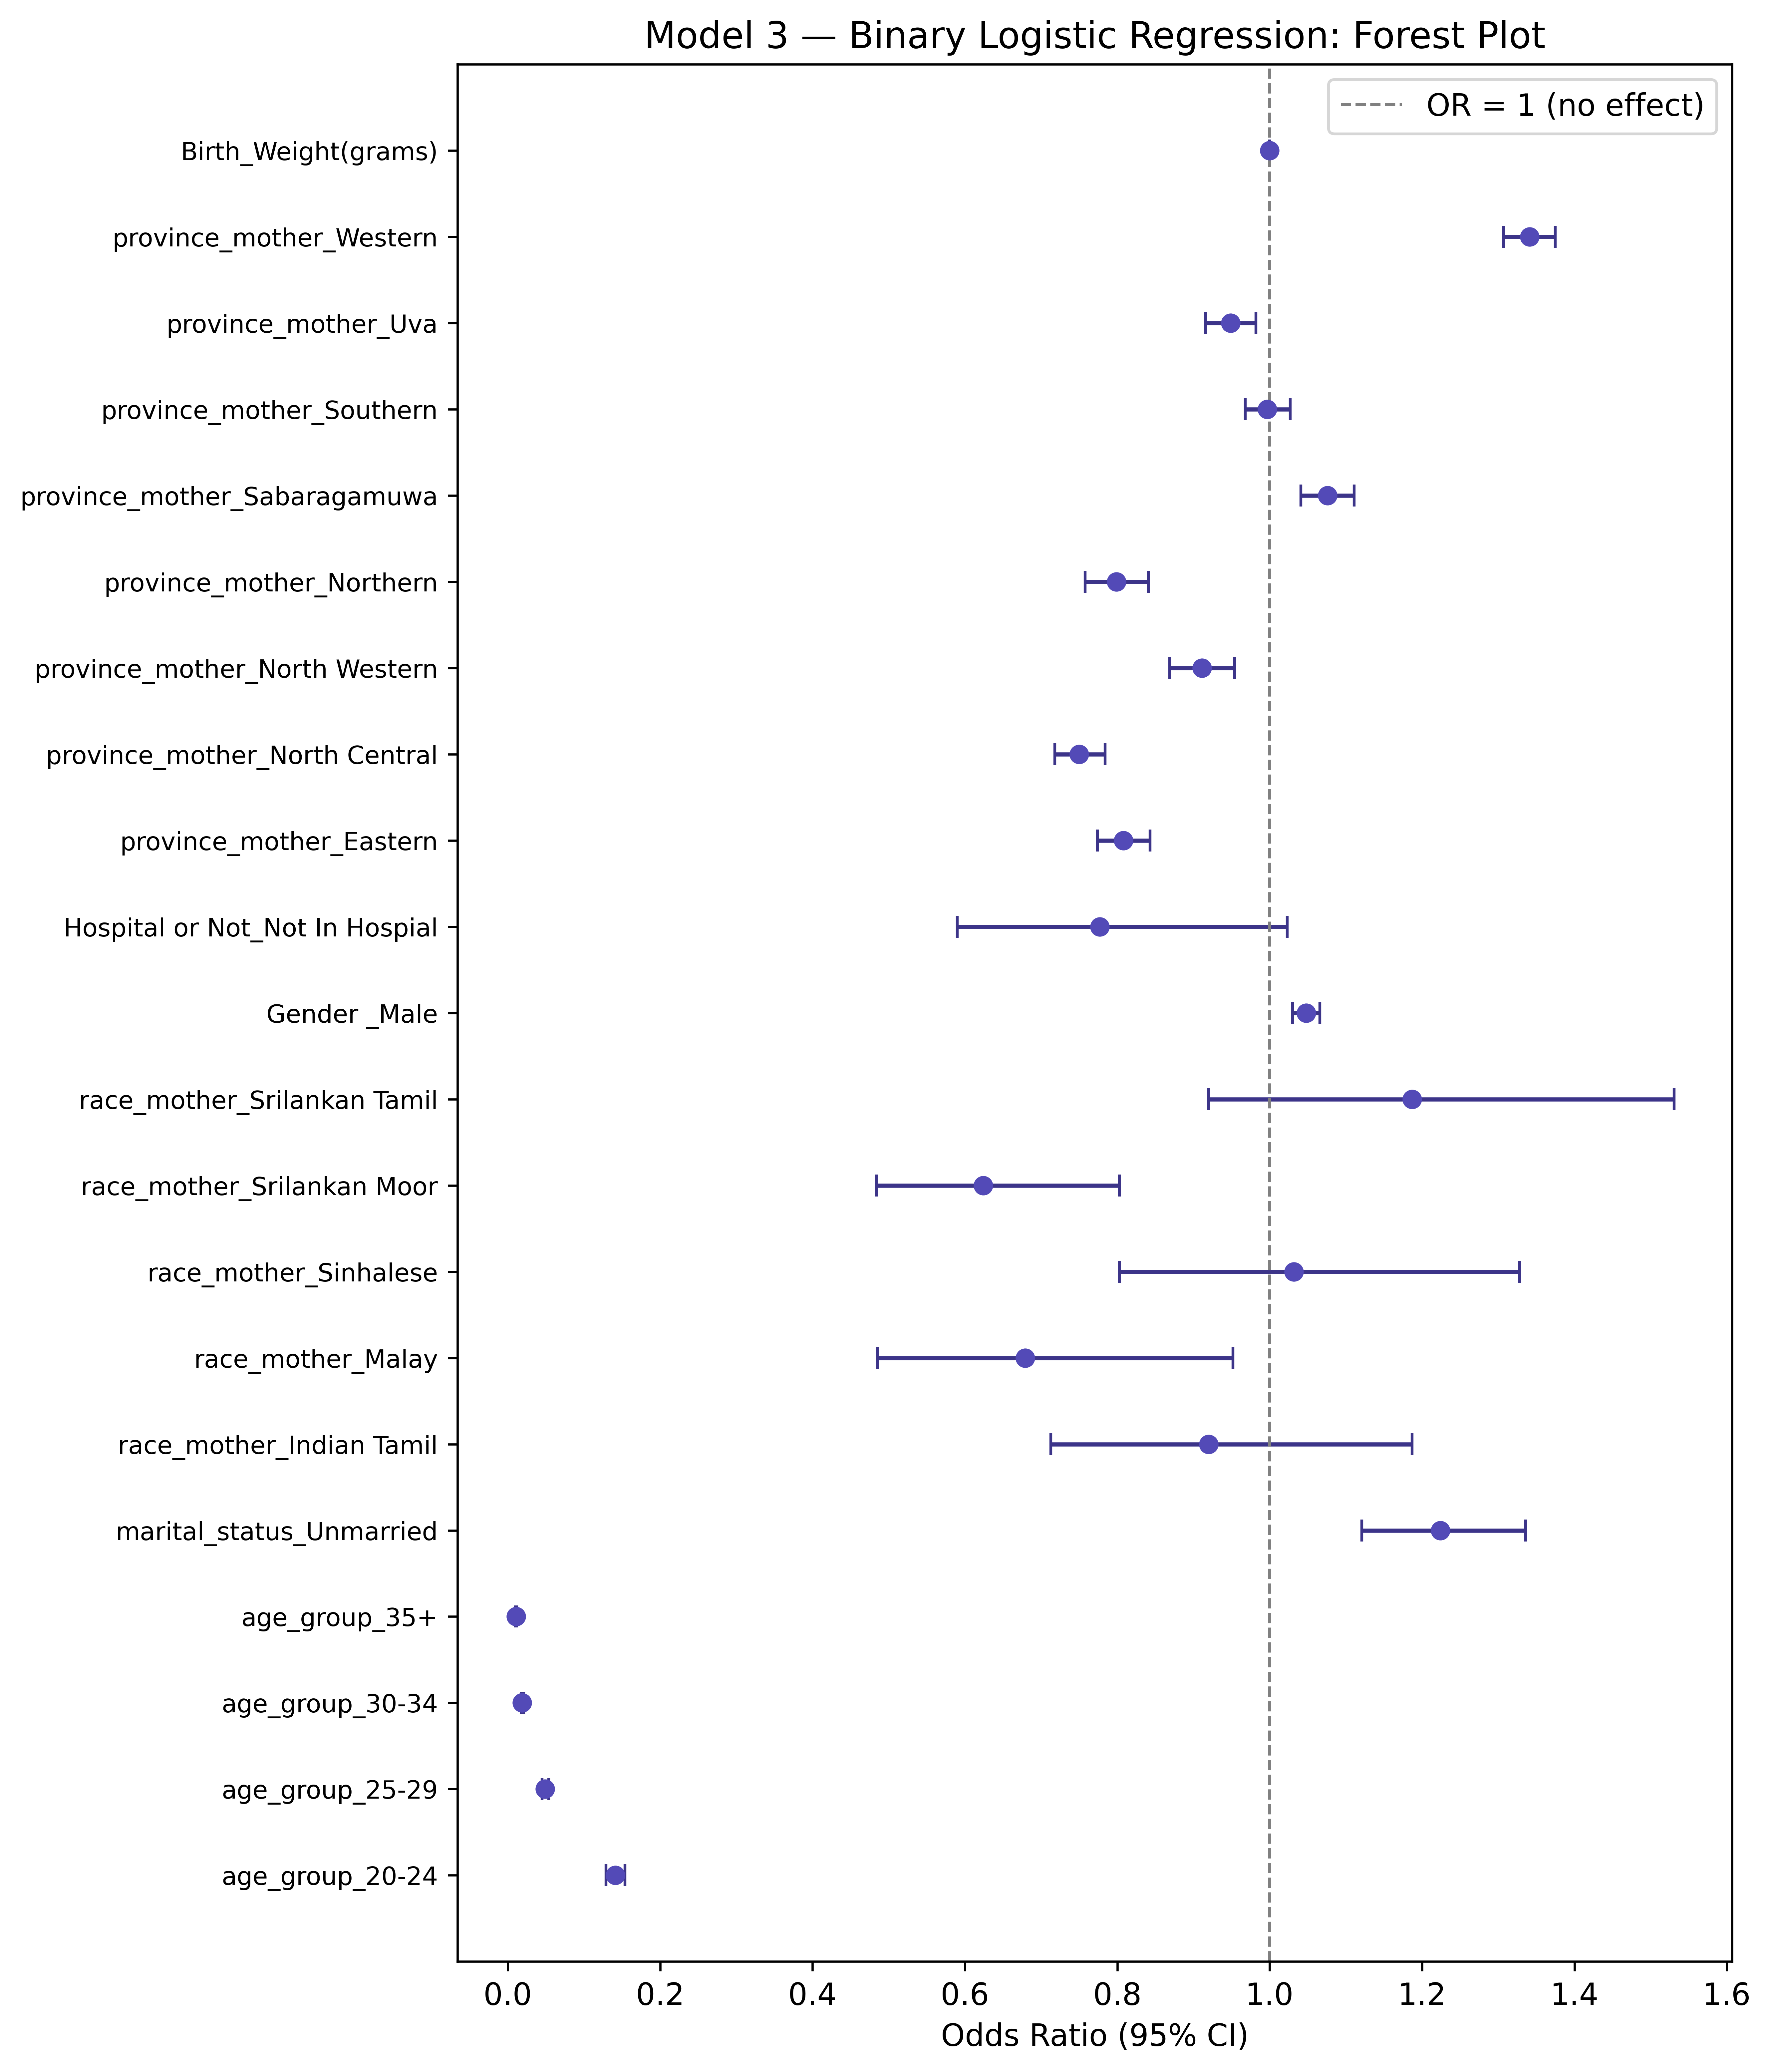
Figure 7.1: Forest plot of odds ratios for Model 3 (Binary Logistic Regression)

Key Predictors by Effect Size
Strongest Positive Associations | OR (95% CI) | Signif. | Strongest Negative Associations | OR (95% CI)
province_mother_Western | 1.34 (1.31-1.38) | *** | age_group_35+ | 0.01 (0.01-0.01)
marital_status_Unmarried | 1.22 (1.12-1.34) | *** | age_group_30-34 | 0.02 (0.02-0.02)
race_mother_Srilankan Tamil | 1.19 (0.92-1.53) |  | age_group_25-29 | 0.05 (0.04-0.05)
province_mother_Sabaragamuwa | 1.08 (1.04-1.11) | *** | age_group_20-24 | 0.14 (0.13-0.15)
Gender _Male | 1.05 (1.03-1.07) | *** | race_mother_Srilankan Moor | 0.62 (0.48-0.80)

Strongest Effects
Strongest Positive Effect: province_mother_Western (OR = 1.341) - This predictor has the largest positive association with being first-born.
Strongest Negative Effect: age_group_35+ (OR = 0.011) - This predictor has the largest negative association with being first-born (i.e., strongest association with being later-born).

Note on Interpretation
The forest plot displays odds ratios on a logarithmic scale. Confidence intervals that do not cross the vertical line at OR=1 indicate statistically significant associations at the 5% significance level. The points represent the point estimates, while the horizontal bars represent the 95% confidence interval width.
The purple color scheme (#534AB7 for points, #3C3489 for error bars) was used for the binary logistic model to distinguish it from previous analyses.

Clinical/Substantive Significance
When interpreting forest plots, consider both statistical and substantive significance:
• OR between 0.95 and 1.05: Minimal practical effect even if statistically significant
• OR between 0.67 and 1.50: Small to moderate practical effect
• OR < 0.67 or > 1.50: Substantial practical effect
• OR < 0.50 or > 2.00: Large practical effect

Saved Files
The following image files were saved to disk:
• fig7_binary_forest.png - Forest plot (150 DPI)
• fig7_binary_forest_hd.png - High-resolution version for publication (600 DPI)

Publication Quality
The forest plot has been saved at 600 DPI for publication quality. For inclusion in manuscripts, consider the following:
• Adjust figure size in the code if needed (currently 9×10.5 inches)
• Colors can be customized to match journal guidelines
• The plot uses a purple color scheme (#534AB7 for points, #3C3489 for error bars)

7.4 ROC Curve & Model Discriminative Ability
The Receiver Operating Characteristic (ROC) curve evaluates the discriminative ability of the binary logistic regression model. It plots the True Positive Rate (Sensitivity) against the False Positive Rate (1 - Specificity) at various threshold settings.
AUC (Area Under the Curve) Interpretation:
• AUC = 0.50: No discriminative ability (random guessing)
• 0.70 ≤ AUC < 0.80: Acceptable discrimination
• 0.80 ≤ AUC < 0.90: Good discrimination
• AUC ≥ 0.90: Excellent discrimination

ROC Curve
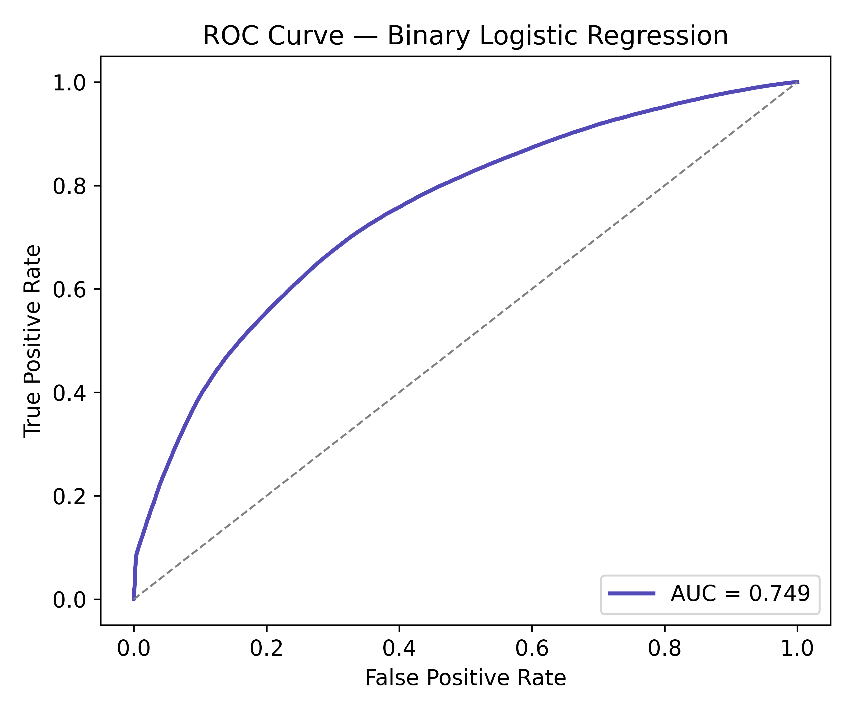
Figure 7.2: ROC Curve for Binary Logistic Regression Model

Area Under the Curve (AUC) Results
Metric | Value
AUC Score | 0.7493
Discriminative Ability | Acceptable
✓ The model shows acceptable discriminative ability (AUC = 0.749)
The model can effectively distinguish between first-born and later-born cases with 74.9% accuracy (where 50% is random guessing).

Optimal Cutoff Analysis (Youden's J Statistic)
The optimal probability cutoff maximizes sensitivity and specificity simultaneously using Youden's J statistic (J = Sensitivity + Specificity - 1).
Metric | Value at Optimal Cutoff
Optimal Probability Cutoff | 0.4133
Sensitivity at Cutoff | 0.6926
Specificity at Cutoff | 0.6817
Accuracy at Cutoff | 0.6861
Precision at Cutoff | 0.5997
F1 Score at Cutoff | 0.6428
At the optimal cutoff probability of 0.413, the model achieves sensitivity = 0.693 and specificity = 0.682. This means it correctly identifies 69.3% of first-born cases and 68.2% of later-born cases.

Model Performance Summary
Performance Metric | Value | Rating
AUC (Area Under ROC Curve) | 0.7493 | Acceptable
Accuracy (at optimal cutoff) | 0.6861
Sensitivity/Recall (at optimal cutoff) | 0.6926
Specificity (at optimal cutoff) | 0.6817
Precision (at optimal cutoff) | 0.5997
F1 Score (at optimal cutoff) | 0.6428

Clinical/Substantive Utility
The model demonstrates acceptable discriminative ability (AUC = 0.749).
This level of discrimination suggests the model could be useful for risk stratification and identifying women at higher or lower probability of first-born status. The optimal cutoff provides a practical threshold for classification in clinical or research settings.

Limitations of ROC Analysis
While ROC curves and AUC provide valuable information about model discrimination, they have limitations:
• AUC does not reflect calibration (whether predicted probabilities match observed outcomes)
• ROC curves may be overly optimistic in imbalanced datasets
• Clinical utility depends on the specific cutoff and context
• Cross-validation is recommended for unbiased performance estimates
Consider complementing ROC analysis with calibration plots and decision curve analysis.

Saved Files
The following files were saved:
• fig8_roc_curve.png - ROC curve (150 DPI)
• fig8_roc_curve_hd.png - High-resolution ROC curve (600 DPI)

7.5 Confusion Matrix & Classification Performance
The confusion matrix and classification report provide a comprehensive evaluation of the binary logistic regression model's predictive performance at the default threshold of 0.5 (where probabilities ≥ 0.5 are classified as first-born).

Confusion Matrix
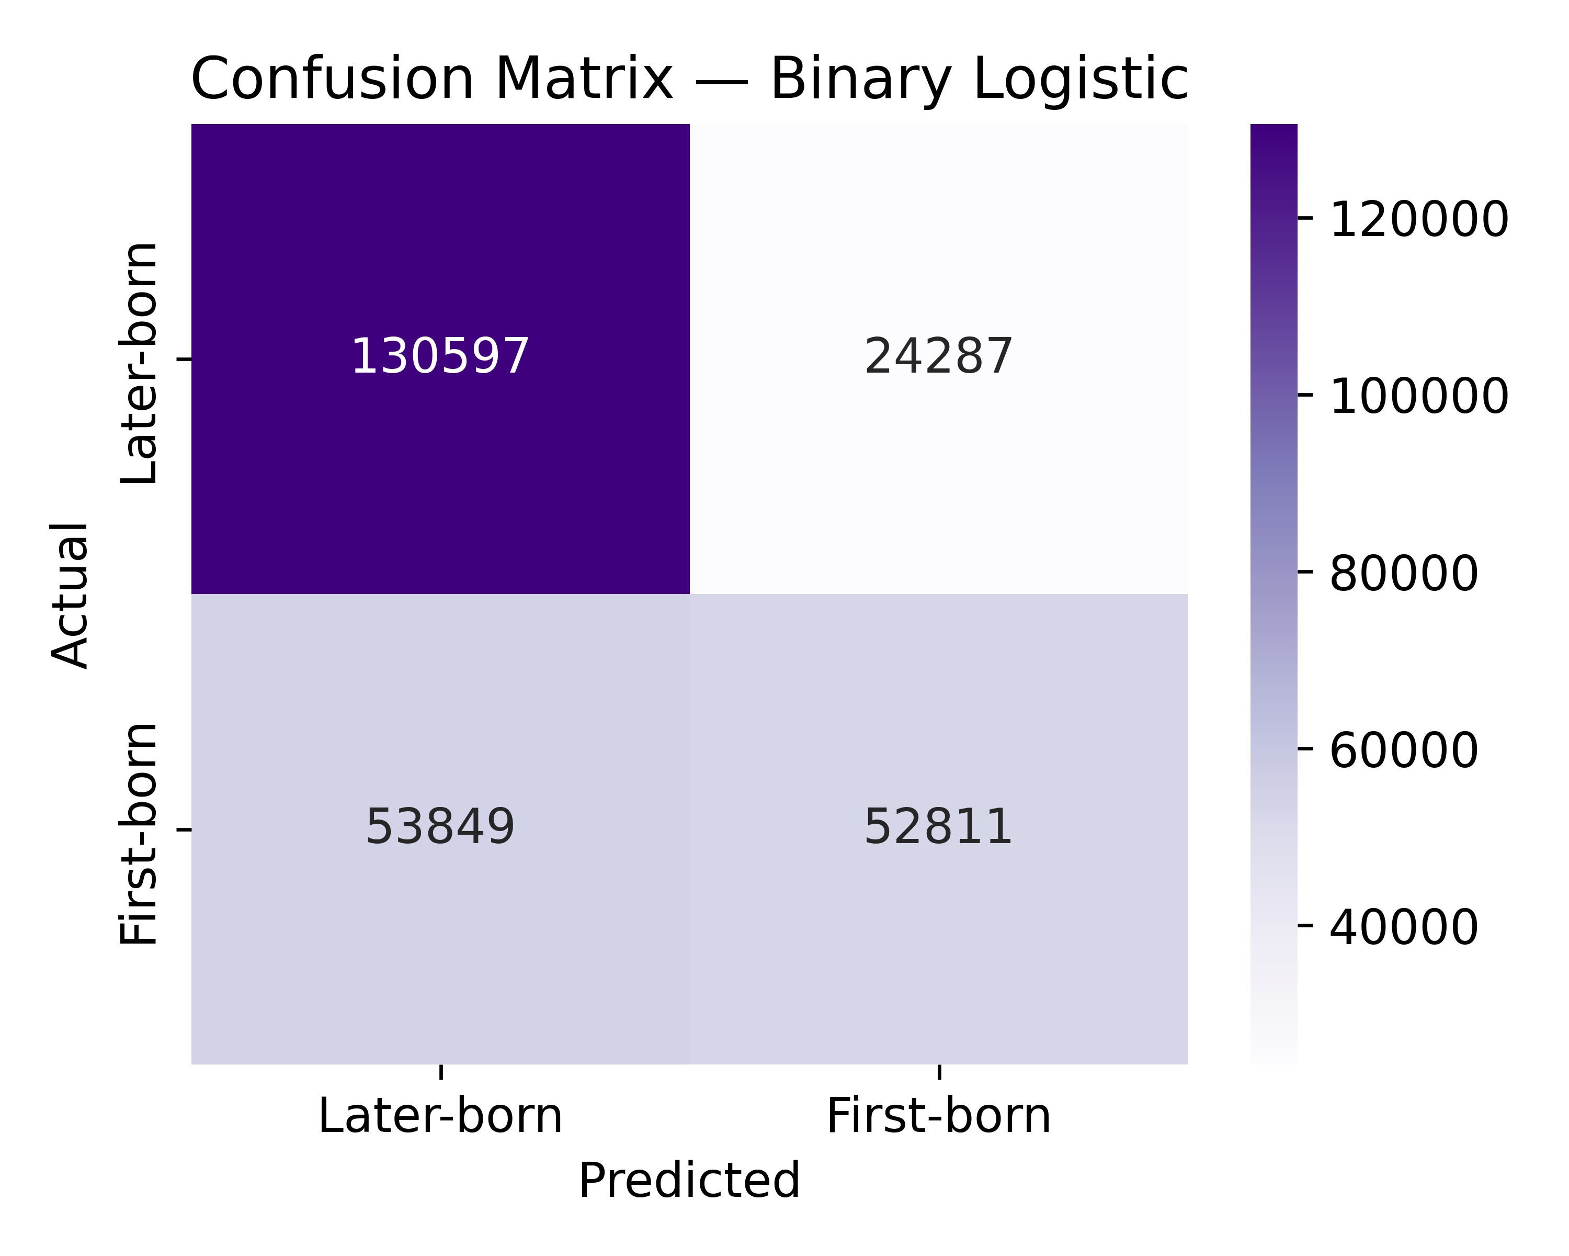
Figure 7.3: Confusion Matrix for Binary Logistic Regression Model (Threshold = 0.5)

Confusion Matrix Interpretation
Metric | Count | Interpretation
True Negatives (TN) | 130597 | Correctly predicted later-born
False Positives (FP) | 24287 | Incorrectly predicted first-born (Type I error)
False Negatives (FN) | 53849 | Incorrectly predicted later-born (Type II error)
True Positives (TP) | 52811 | Correctly predicted first-born

Classification Performance Metrics
Metric | Value | Percentage | Interpretation
Accuracy | 0.7013 | 70.1% | Overall correct predictions
Misclassification Rate | 0.2987 | 29.9% | Overall incorrect predictions
Sensitivity (Recall) | 0.4951 | 49.5% | Correctly identified first-born cases
Specificity | 0.8432 | 84.3% | Correctly identified later-born cases
Precision | 0.6850 | 68.5% | Accuracy of first-born predictions
Negative Predictive Value | 0.7081 | 70.8% | Accuracy of later-born predictions
F1 Score | 0.5748 | 57.5% | Harmonic mean of precision and recall
Balanced Accuracy | 0.6692 | 66.9% | Average of sensitivity and specificity
Matthews Correlation | 0.3647 |  | Correlation between actual and predicted

Detailed Classification Report
Class | Precision | Recall | F1-Score | Support
Later-born | 0.7081 | 0.8432 | 0.7697 | 154884
First-born | 0.6850 | 0.4951 | 0.5748 | 106660
Accuracy |  |  | 0.7013 | 261544
Macro Avg | 0.6965 | 0.6692 | 0.6723
Weighted Avg | 0.6986 | 0.7013 | 0.6902

Error Analysis
Type I Errors (False Positives): 24287 cases were incorrectly classified as first-born when they were actually later-born.
Type II Errors (False Negatives): 53849 cases were incorrectly classified as later-born when they were actually first-born.
The model tends to under-predict first-born cases (more False Negatives).

Threshold Considerations
The current analysis uses the default threshold of 0.5. Based on the ROC analysis in Section 7.4, the optimal threshold was 0.413 using Youden's J statistic.
At the optimal threshold:
• Sensitivity: 0.6926 vs current 0.4951
• Specificity: 0.6817 vs current 0.8432
Depending on the research question, one may prefer a threshold that prioritizes sensitivity (identifying first-born cases) or specificity (identifying later-born cases).

Performance Summary
Overall Performance Rating: Good
The binary logistic regression model achieves 70.1% overall accuracy with 49.5% sensitivity and 84.3% specificity. The F1 score of 0.575 indicates moderate balance between precision and recall.

Saved Files
The following files were saved:
• fig9_confusion_matrix.png - Confusion matrix (150 DPI)
• fig9_confusion_matrix_hd.png - High-resolution confusion matrix (600 DPI)

